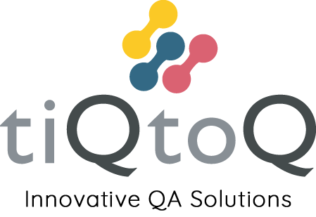

Code of Conduct

Version: 1.01
Date: 1st June 2022

The aim of the Company’s Code of Conduct is to set out the guiding principles for the conduct of our business activities. It applies to our corporate activity as well as the individual behaviour of employees and subcontractors in their daily work activities.
tiQtoq has five core values that we run our company by. They define how we approach our work and our relationships with everyone we work with.

• Integrity
We will act with integrity in all our interactions. With clients, with colleagues and with suppliers.

• Respect
We will work with respect in all our activities. We will not discriminate and actively promote equality and diversity.

• Responsibility
We will take responsibility for our actions. We will be accountable for the decisions we make as a business.

• Ingenuity
We strive at all times to create the optimal, most ingenious solutions to the task at hand

• Care
Above all we will take care. Take care of our customers, take care of our colleagues, take care of our environment, and take care of the communities we work in.

With these core values in mind, the following sets out the minimum standard we expect.

We do the right thing

We always obey the law. We are a responsible company, acting with integrity towards our customers, employees, suppliers, and others in the general communities in which we operate and who can be affected by our activities. We are committed to act fairly and responsibly. We expect the same of everyone who works for us.
If you see or suspect anything that violates any of these principles let us know.
Our communities also includes our online communities. When you are posting online remember that your responsibility to tiQtoQ doesn’t end when you’re not working. Post sensibly.
If you have a problem with something at tiQtoQ, speak to someone in the leadership team. We will listen.

We treat each other with respect

We want a great work environment in which our staff feel happy and secure. To that end we have a zero tolerance for any forms of bullying, intimidation, or harassment. If you are a victim of, or are aware of someone being a victim, please speak to any member of the leadership team.

We work in an environment that is inclusive and diverse

We aim to treat everyone equally and with the same attention, courtesy, and respect regardless of their age, disability, gender, marital status, race, racial group, colour, ethnic or national origin, nationality, religion, belief or sexual orientation.
Every employee has an equal opportunity for personal recognition and career development, regardless of personal background or belief. The same policy applies to recruitment of employees. No form of discrimination will be tolerated.
We are committed to complying in both letter and spirit with all anti-discrimination legislation.
If you are aware of anything that may jeopardise this, speak to one of the leadership team.

We work lawfully

We comply with all applicable laws and regulations wherever we work. If it’s not legal, don’t do it. If you’re not sure, ask. If you know or suspect anyone else is acting illegally, it’s vital that you let one of the leadership team know.
We have a separate policy on whistleblowing that details our approach to this.

We reject bribery, do not accept gifts and avoid conflicts of interest

Bribes in any form are unacceptable. Employees should immediately reject any demand or offer for such a bribe and report it to the leadership team
In general, personal gifts or favours of any material commercial value may not be made or accepted by any staff. Any gift of an estimated value of £20 or more must be reported. ‘Gift’ includes hospitality of any nature. An exception may be made with prior approval of the leadership team on the occasions when refusal of the gift or favour would be to the detriment of the legitimate business interests of tiQtoQ. In determining if the exception should be made, local customs may be taken into account.
tiQtoQ expects its staff to be fully dedicated and committed to our business and work, and to avoid any conflict of interest with this commitment. Any engagement outside tiQtoQ and any financial interest (direct or indirect such as via a family member or acquaintance) which could give rise to a conflict of interest should always be promptly disclosed to the leadership team. Staff are not allowed to have a direct or indirect financial interest in a supplier or competing company with the exception of shares in a public company.

We keep our data and equipment secure

Where it is your responsibility, records of transactions should be maintained in an accurate, complete, transparent and timely manner in accordance with our accounting principles.
Customer communications and data are to be kept secure at all times. Unnecessary disclosure could have serious implications for our business. If you are worried about data security, or are uncertain about a process, speak to the leadership team for guidance.
Laptops, computers and mobile phones (and the data on them) provided to you by tiQtoQ remain the property of the company. Limited personal use is permitted provided it does not impact on your work performance or does not violate any of our other policies.

We support our communities

As a company we strive to be a good neighbour and have a positive impact in the communities we operate in. Alongside providing good jobs to strengthen communities we also seek to help local charitable and support organisations where we can. If you’re involved in a local group let one of the leadership team know.

We look after the environment

tiQtoQ is committed to operate and provide its services in as sustainable and environmentally friendly manner as possible. We follow all laws and regulations related to the environment and strive to follow best practices that minimise our environmental impact.

