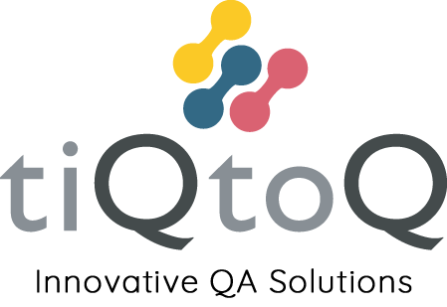

Modern Slavery Policy

Version: 1.01
Date: 1st June 2022

Introduction
This statement is made pursuant to s.54 of the Modern Slavery Act 2015 and sets out the steps that TiQtoQ has taken and is continuing to take to ensure that modern slavery (also known as human trafficking) is not taking place within our business or supply chain.

Modern slavery encompasses slavery, servitude, human trafficking and forced labour. TiQtoQ has no tolerance to any form of modern slavery.

TiQtoQ is committed to acting ethically and with integrity and transparency in all business dealings and to putting effective systems and controls in place to safeguard against any form of modern slavery taking place within the business or the company’s suppliers.

Our Business
TiQtoQ is a software testing and quality assurance consulting company operating throughout the UK. TiQtoQ has a small number of suppliers, which include national and international service providers, third party consultants, and computing equipment suppliers.

What is this policy?
The Modern Slavery Act 2015 came into effect in March 2015. The legislation enhances the support and protection for victims of human trafficking and enslavement. tiQtoQ is wholly supportive of the Act. This policy will be reviewed annually to ensure compliance is maintained.
We will continue to monitor all and record anti-slavery checks for all personnel working within our business. In addition to this we will ensure any sub consultants reflect our standards.

Responsibility for the policy
The directors have overall responsibility for ensuring this policy complies with our legal and ethical obligations, and that all those under our control comply with it. Management at all levels are responsible for ensuring those reporting to them, understand and comply with this policy.

Our Values
tiQtoQ operates with the following core values:

Integrity
We will act with integrity in all our interactions. With clients, with colleagues and with suppliers.

Respect
We will work with respect in all our activities. We will not discriminate and actively promote equality and diversity.

Responsibility
We will take responsibility for our actions. We will be accountable for the decisions we make as a business.

Ingenuity
We strive at all times to create the optimal, most ingenious solutions to the task at hand

Care
Above all we will take care. Take care of our customers, take care of our colleagues, take care of our environment and take care of the communities we work in.

In addition to our relevant core value above, we operate a number of internal policies to ensure that we are conducting business in an ethical and transparent manner. These include:

Whistleblowing policy
We operate a whistleblowing policy so that all employees know that they can raise concerns about how colleagues are being treated, or practices within our business or supply chain, without fear of reprisals.

Anti-bribery and Corruption
It is our policy to conduct all of our business in an honest and ethical manner. We take a zero-tolerance approach to bribery and corruption and are committed to acting professionally, fairly and with integrity in all our business dealings and relationships wherever we operate and implementing and enforcing effective systems to counter bribery. We will uphold the laws of the UK, including the Bribery Act 2010, in respect of our conduct

Processes to Combat Trafficking and Slavery
We are committed to providing our staff with a salary which, as a minimum, meets the National Living Wage and offering at least statutory leave entitlement. Furthermore, we ensure all our staff have provided their National Insurance number, or Working Visa if they are not British nationals, prior to their employment and perform the necessary checks to determine their eligibility to work in the UK. By checking our employees’ NI numbers or Working Visa’s we know they are legally eligible to work in the UK, and that their salary will be monitored by HMRC.

Our Suppliers
TiQtoQ has only a small number of suppliers and does selective (ad hoc) due diligence which includes carrying out online searches, to ensure the organisation has not been convicted of offenses relating to modern slavery. We ensure the supplier confirms that:

1. They have taken steps to eradicate modern slavery within their business
2. They hold their own suppliers to account over modern slavery
3. They pay their UK employees at least the national minimum wage
4. They pay their employees outside of the UK any prevailing minimum wage applicable within their country of operations

tiQtoQ has a supplier company located in Bangalore, India. India is identified as a medium to high-risk country under the Modern Slavery Index published by the Walk Free Foundation. tiQtoQ has contractually binding undertakings that the supplier and its suppliers and subcontractors abide by the Modern Slavery 2015 Act.

Training and Awareness
tiQtoQ updates relevant employees and associates when contracts and Working Visas are due to expire. Monthly updates are also used to share information instantaneously to all our employees, which means we can distribute awareness bulletins, advice, and guidance on a range of topics, including our stance against forced labour and human trafficking. Training on this policy, and on the risk our business faces from modern slavery in its supply chains, forms part of the induction process for all individuals who work for us.

